**E-Project**

**WATCH HUB**

**User Guide**

**Team Members**

|  |  |
| --- | --- |
| Student1435101 | UBAIDULLAH |
| Student1436820 | MUHAMMAD ARHAM KHAN |
| Student1434937 | MUHAMMAD KAARIM HUSSAIN |
| Student1438944 | MUHAMMAD ASIM |
| Student1439028 | LAIBA ALI |
| Student1457819 | SUNDUS KHALID KHAN |

**Splash Screen**

View Application logo and quick description

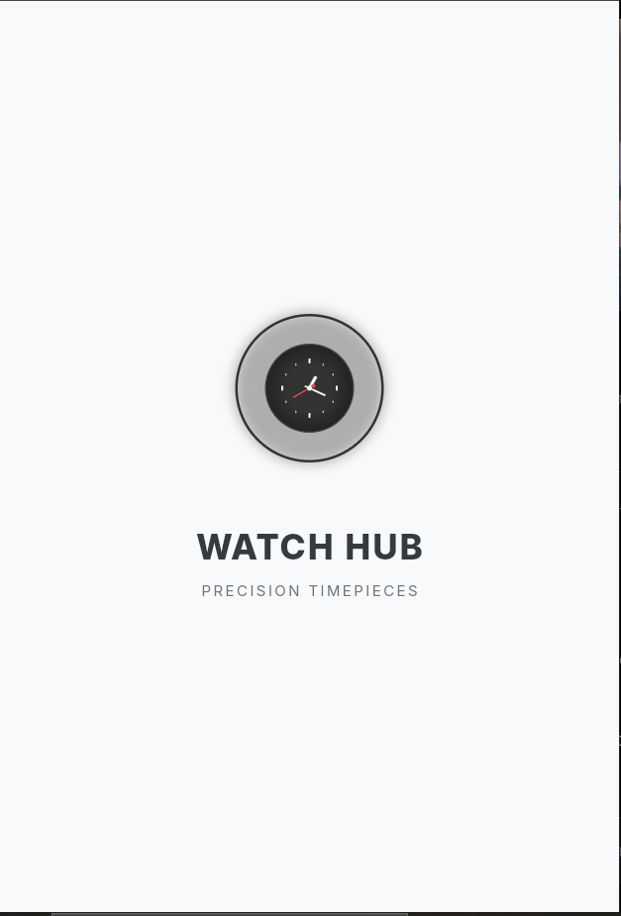

**LOGIN**

Responsible for redirecting users to their panel

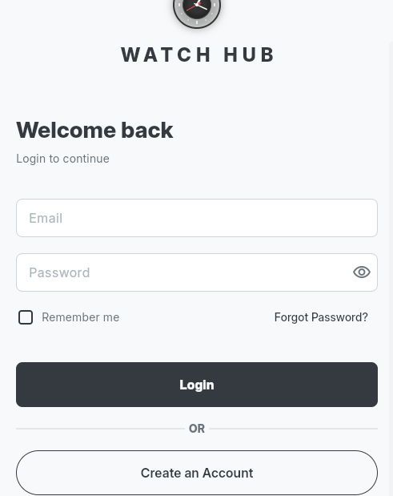

**Sign Up**

For account creation

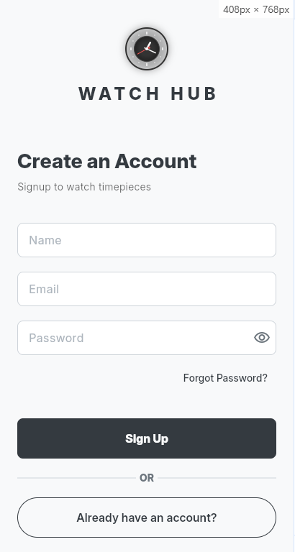

**Home**

Displays users the cards of collections / carousel / watches

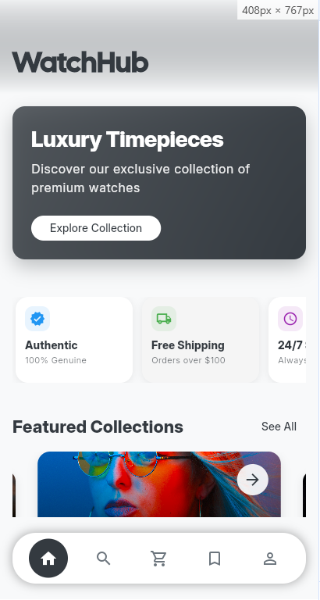

**Search**

Can you use to search different type of watches based on their type, value, brand

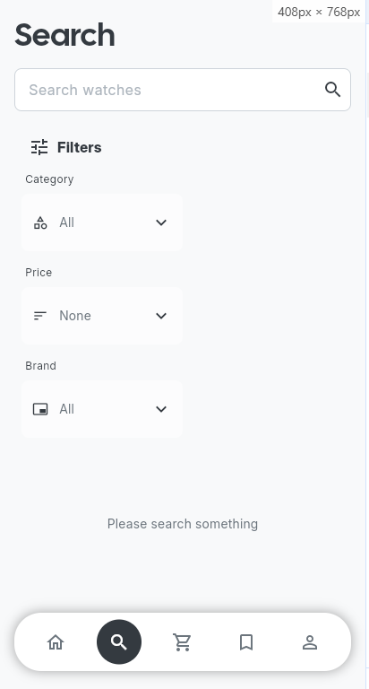

**Wishlist**

Can you be use to save the watches post and can be use later

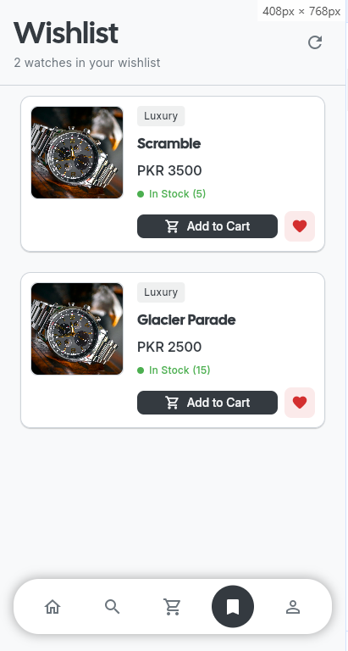

**Profile**

Can view our stats count, update profile information, or proceed to logout

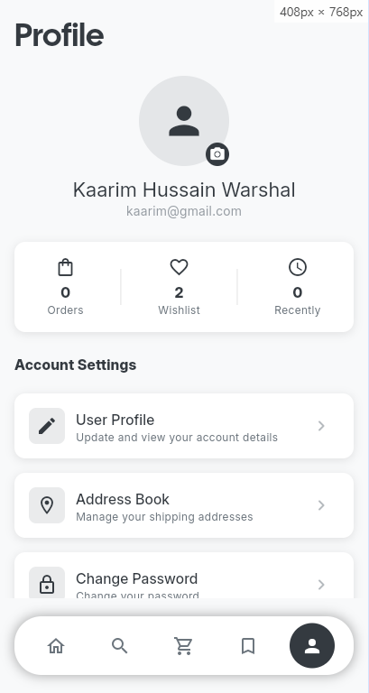

**Watch Details**

Can view in details about the watch brand, specs, etc.

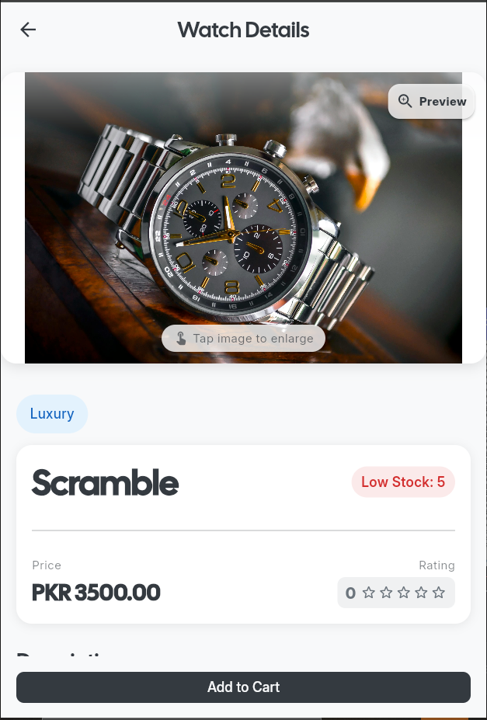

**Watch Review**

Write a review or rate the watch

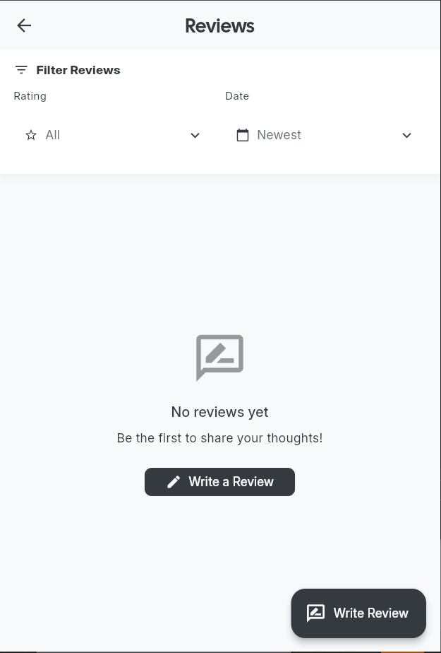

**Review & Rating**

Give rating and review to a watch

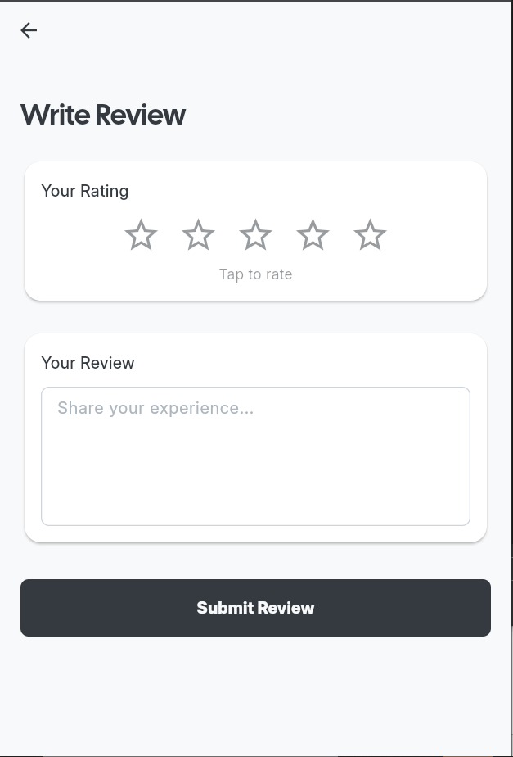

**Forget Password**

Reset your password if forget

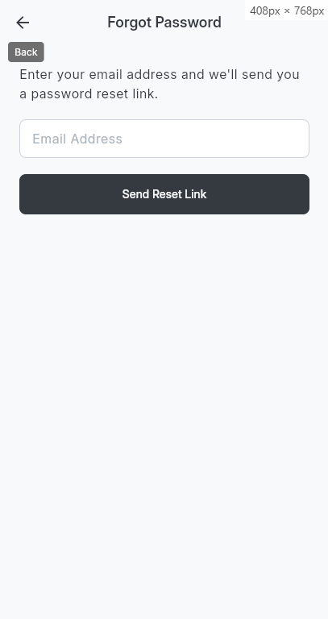

**Admin Dashboard**

Admin can view the application stats like sales, watch count, feedback count, stocks

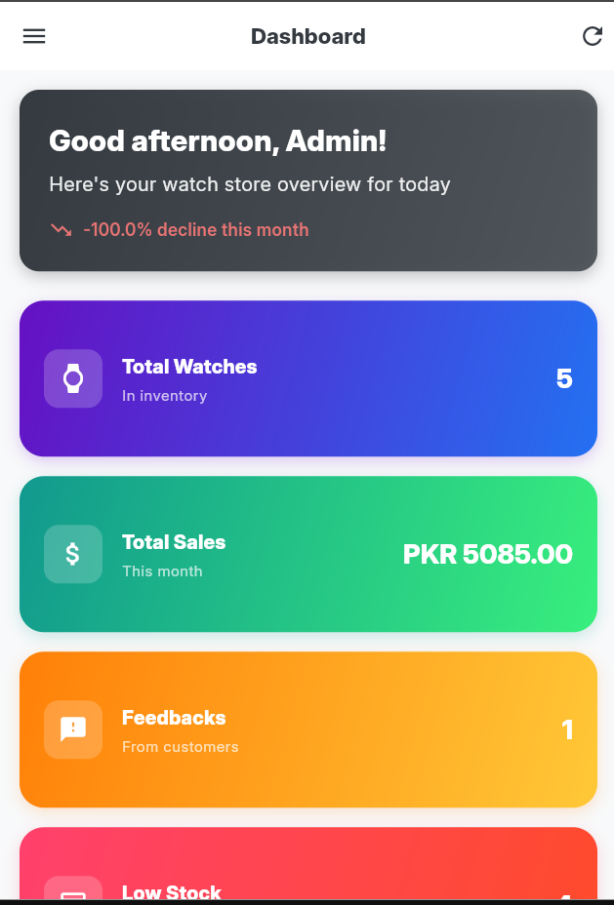

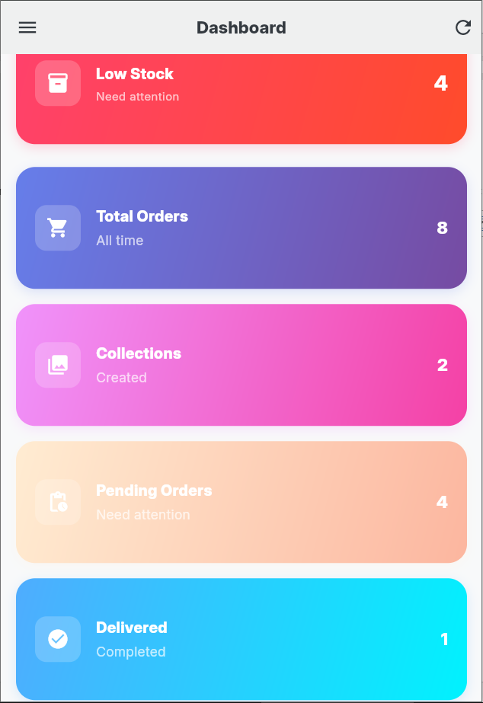

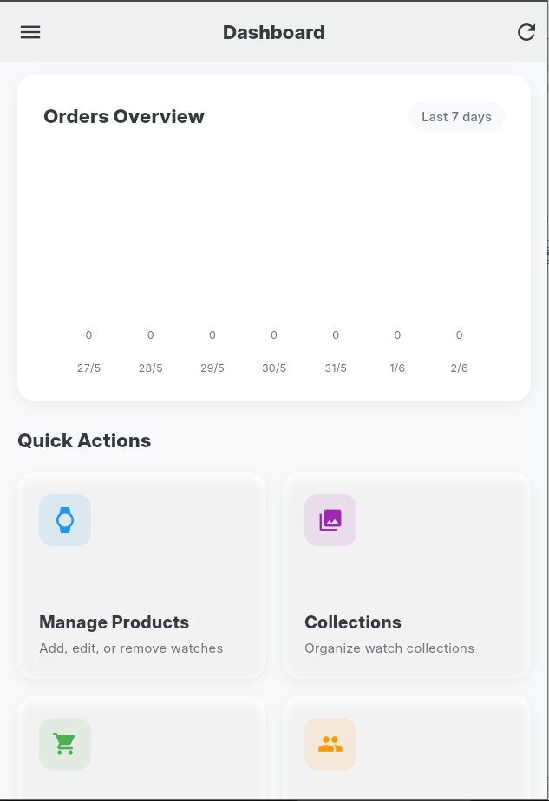

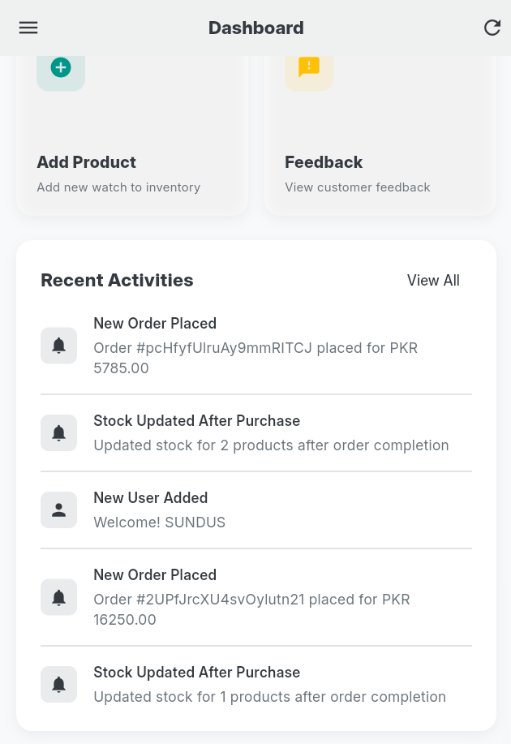

**Admin User View**

Admin can view and delete a specific user

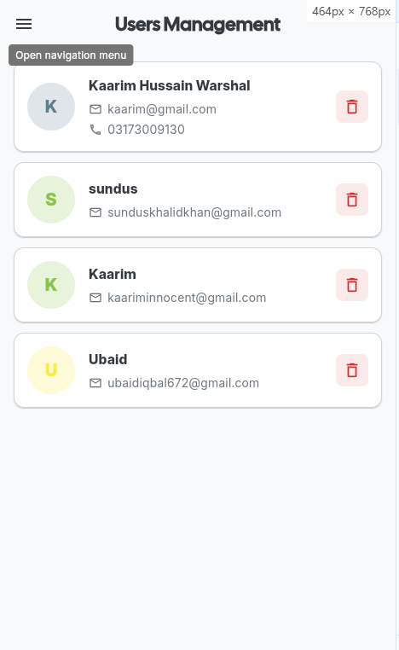

**Admin User Details**

admin can view all the details of the user

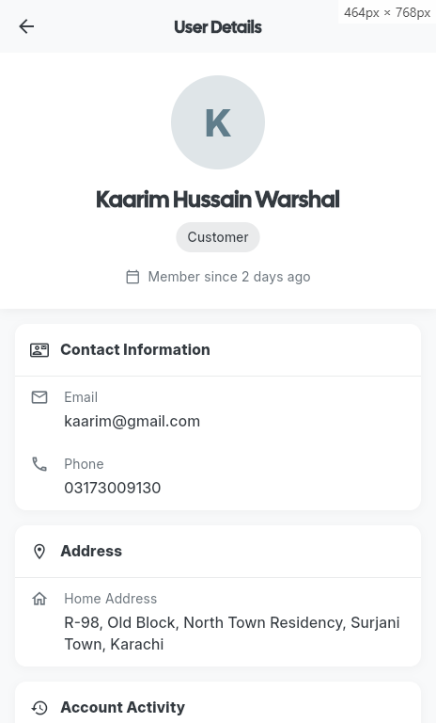

**Admin Watches View**

admin can view, add, update & delete the watches

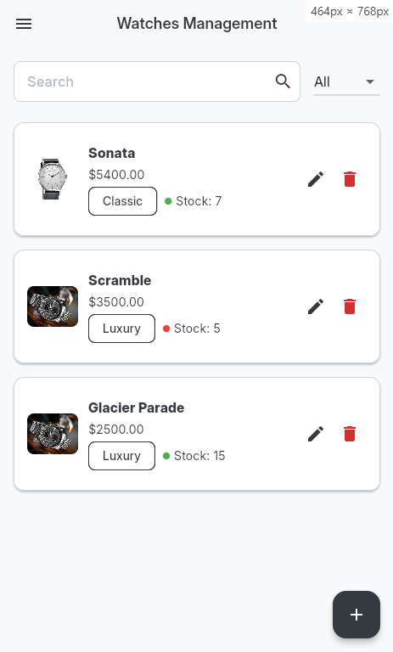

**Admin Watch Add**

Admin can add the details about the watches

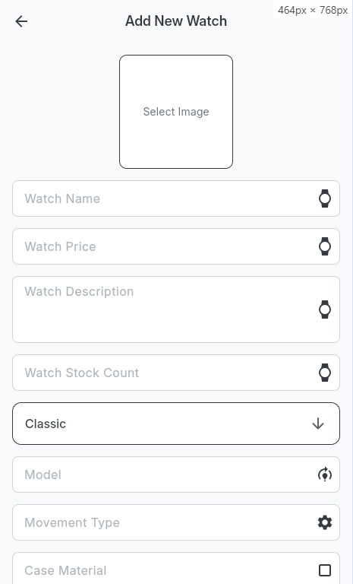

**Admin Edit Watches**

Admin can edit the data of the selected watch

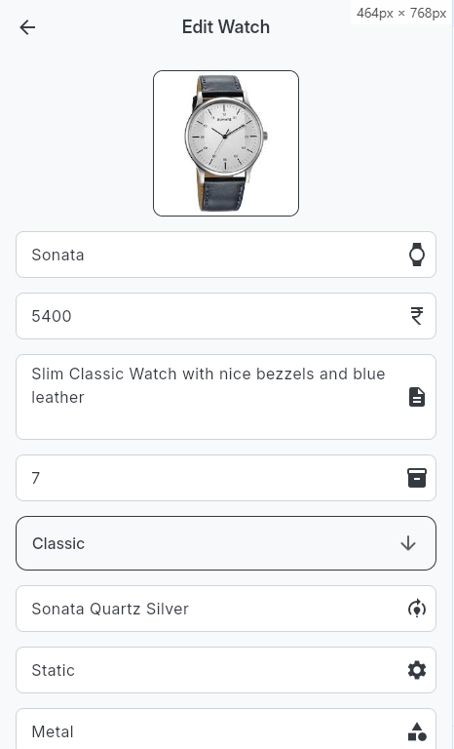

**Admin Feedback**

Admin can view user feedback about different categories like bug report, praise etc.

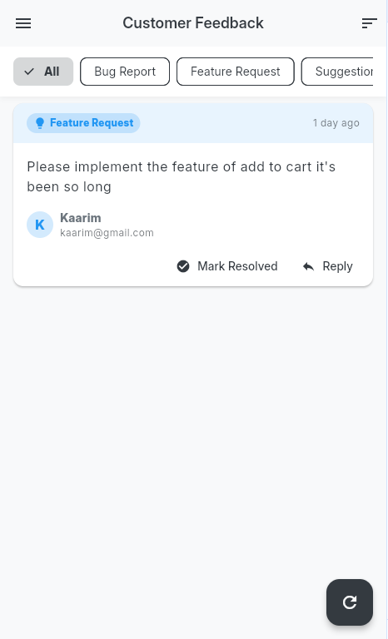

**Feedback**

User can give feedback directly to the admin about the application

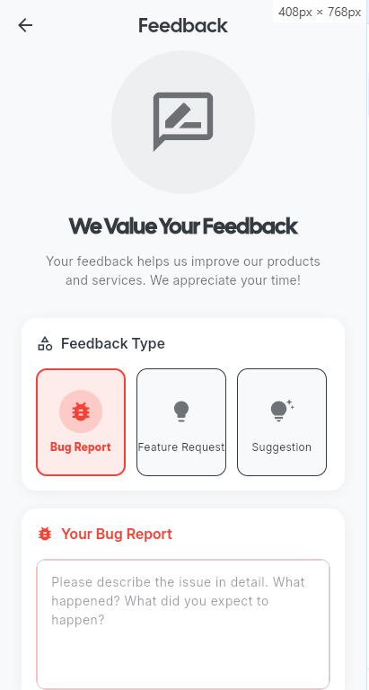

**Add to Cart**

Adding and managing your cart items

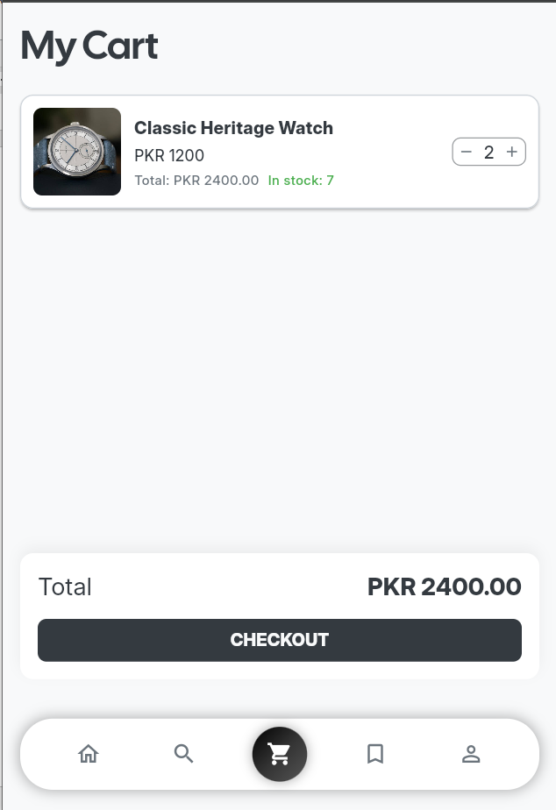

**Checkout Screens**

Completing the purchase and ordering the watch product

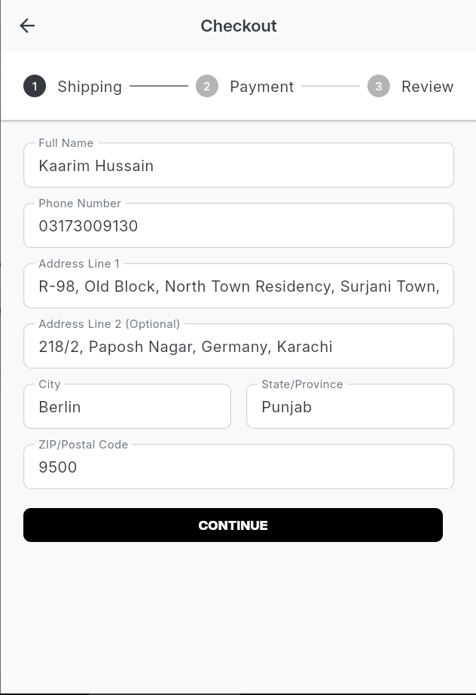

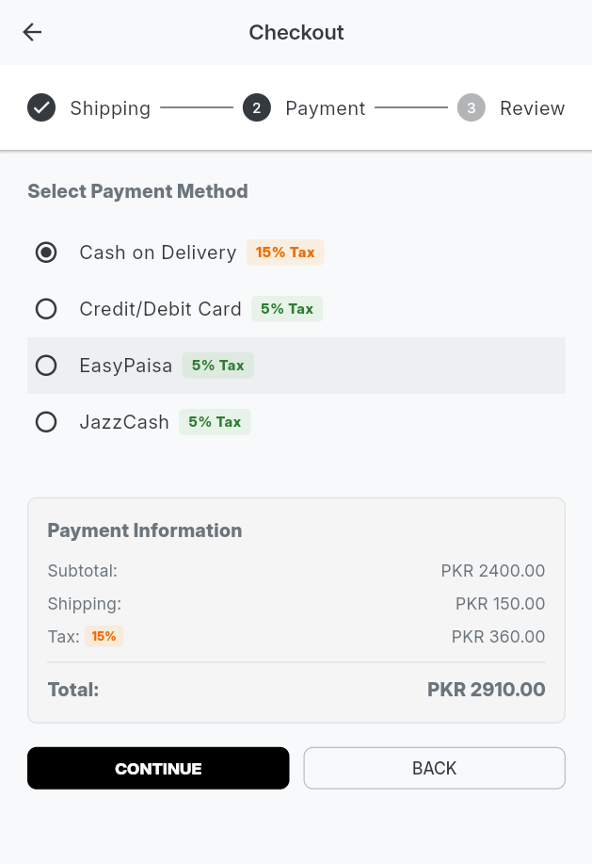

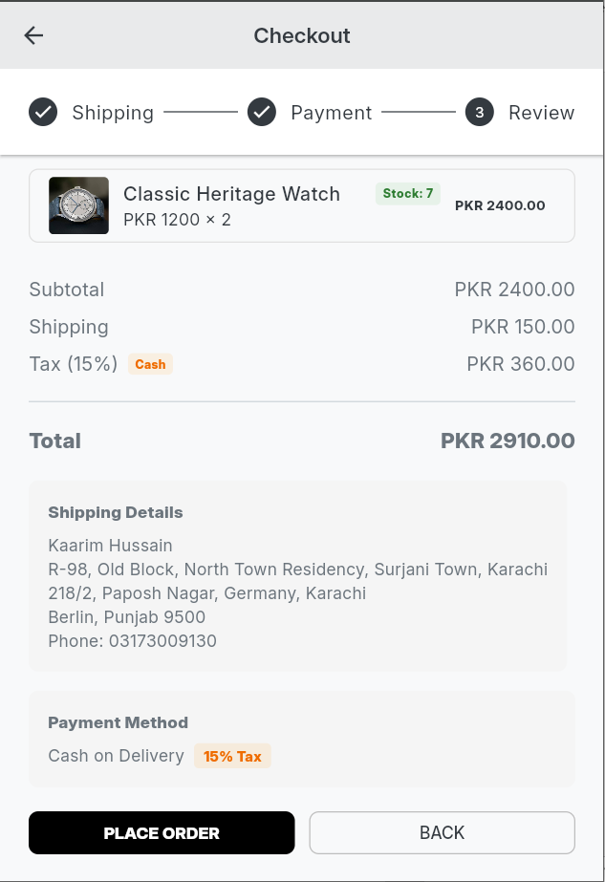

**Admin Orders Screen**

View orders progress, details, and filters them

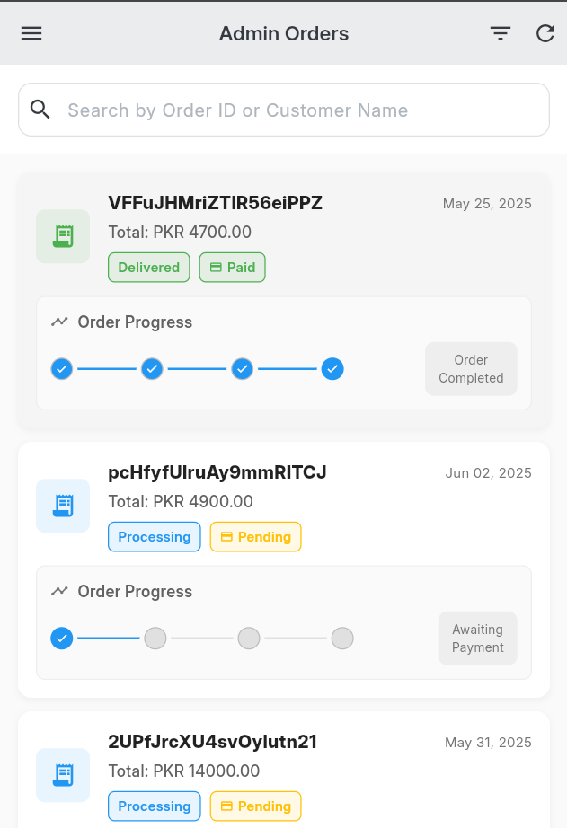

**Admin Order Details Screen**

View the entire detail of the order

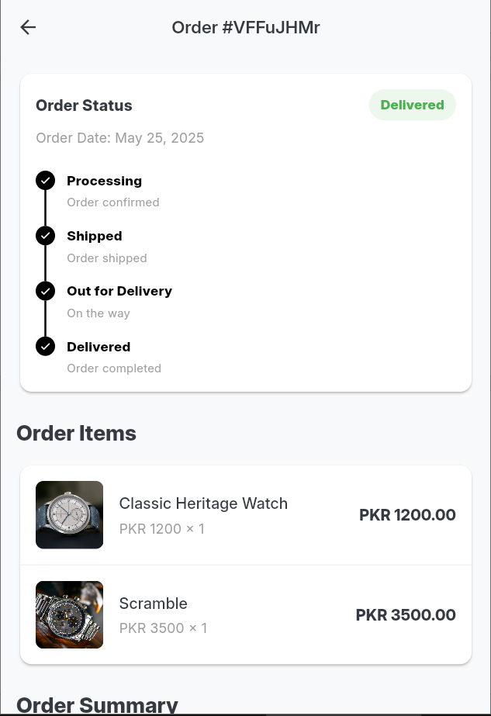

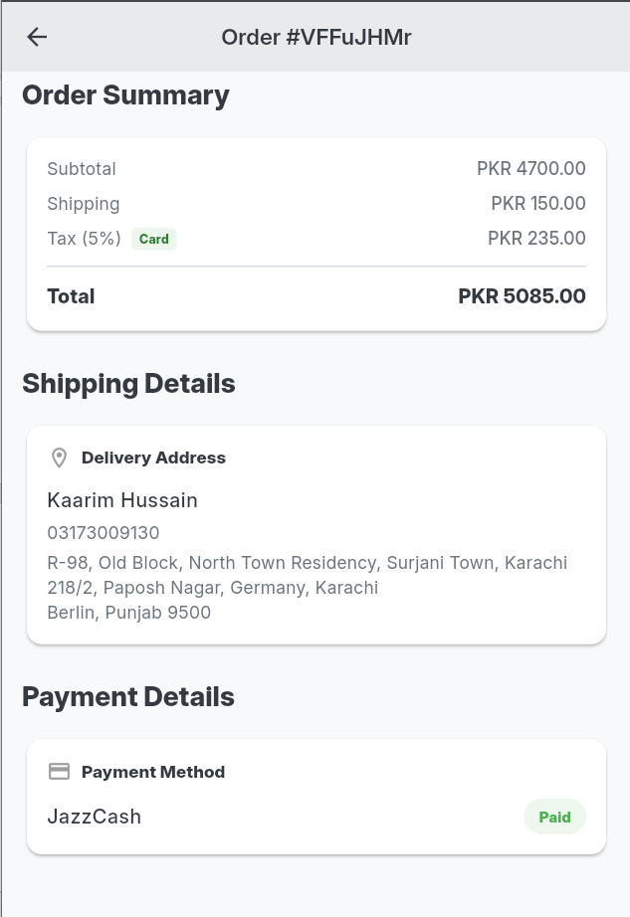

**Admin Watches Collections**

Add collection and the watches inside of it

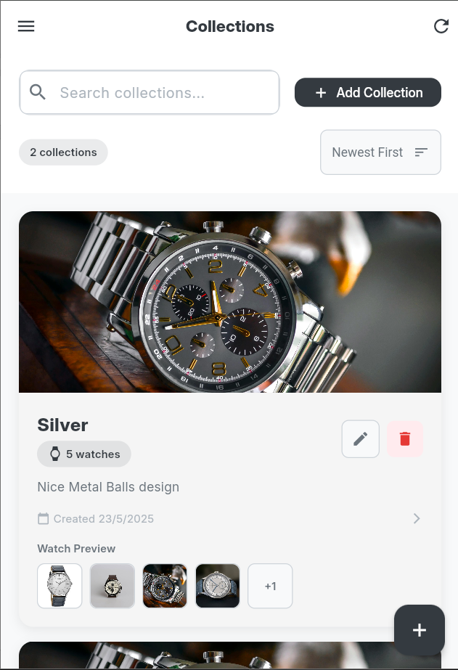

**Collection Screen**

View all the collection created by admin

